Workout to TABATA

In this session, we will demonstrate how we, at Maize South Middle School, use TABATA on a daily basis in our required physical education classes. We have also incorporated TABATA in our 6th grade classes and after school sports practices. This is our second year of using TABATA in our middle school.

Over the summer, a group of teachers started meeting three days a week and they have carried that over to an after school TABATA group. We have observed substantial growth in our fitness testing results and we hope to show that same growth annually.
The TABATA Protocol was developed by Japanese professor Dr. Izumi Tabata to train Olympic speed skaters. One of the benefits of TABATA training is that it will raise your metabolism and heart rate immediately. Since you are performing these exercises at a very high intensity, your body will have to work much harder to keep it up. This will cause your heart to pump faster and your metabolism to jump, which you want if you are planning on losing fat. Your metabolism will stay at that high rate not only during the workout, but after the workout as well.
Proper warm up for TABATA training involves dynamic exercises as opposed to static stretches. TABATA teaches your body to tolerate lactic acid. When you train in a high-intensity zone, your threshold becomes higher. It also keeps your metabolism running on high gear. One of the greatest benefits of anaerobic training is that your body keeps burning fat for 24 hours after your workout.
APPS for Physical Education classes:
Interval Timer Ab Randomizer Seconds Pro
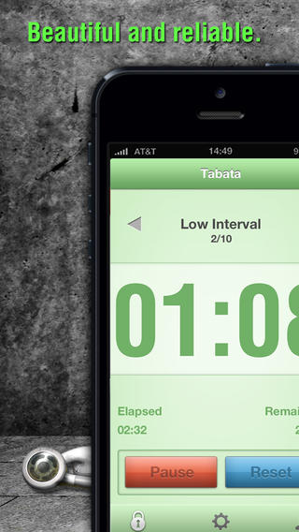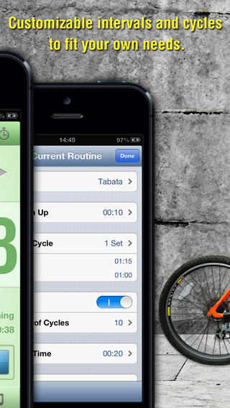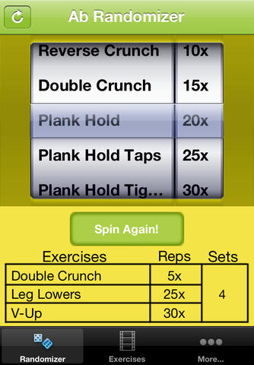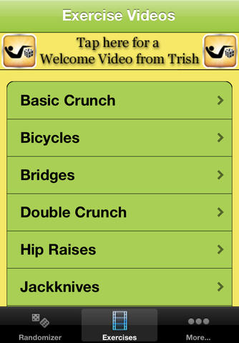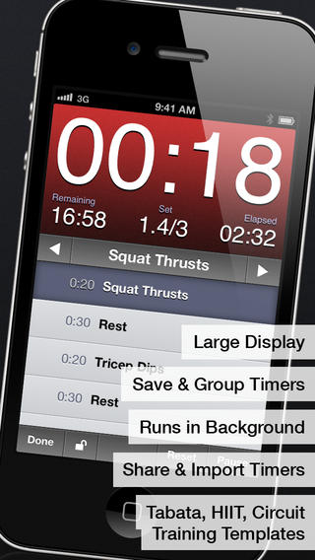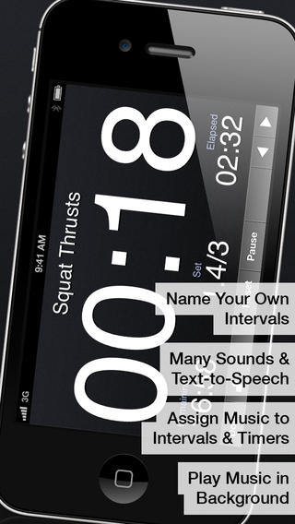
TABATA PRO Full Fitness
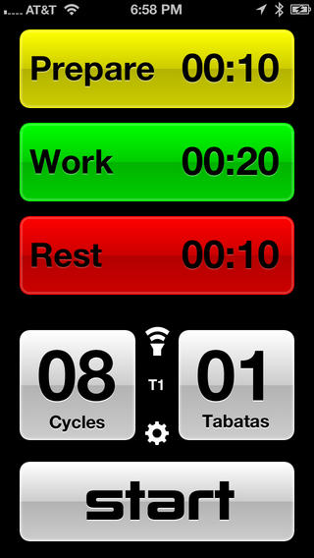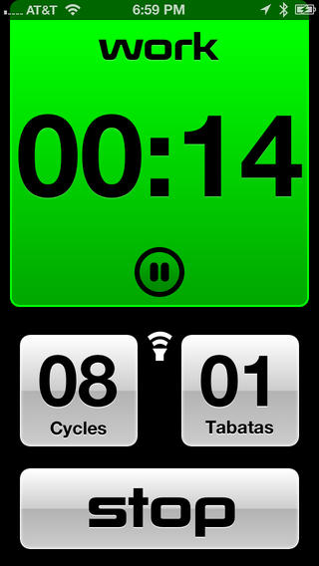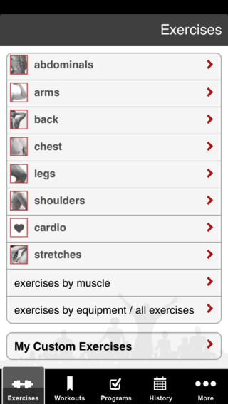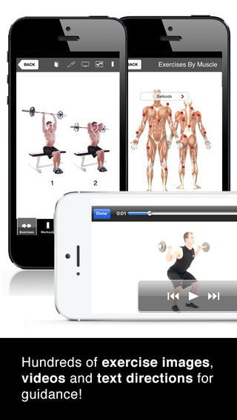

Sample TABATAS to use in your Physical Education classes:

Tabata Set 1: Warm up: 10 minutes jogging, dynamic stretches
1. Burpees
2. Banana superman 3. Mountain Climbers
4. Plank 5. Squat Jumps
Alternate each exercise for 30 seconds, resting 10 seconds in between and repeat for 5 cycles.
Rest for 1 minute and 20 seconds (jog indoor lap)
Estimated Workout Time: 32 Minutes

Tabata Set 2: Warm up: 10 minutes jogging, dynamic stretches
1. Jumping Jacks 2. Sit-ups
3. Downhill Skier 4. Push-ups 5. Slow Squats
Alternate each exercise for 30 seconds, resting 10 seconds in between and repeat for 5 cycles.
Rest for 1 minute and 20 seconds (jog indoor lap)
Estimated Workout Time: 32 Minutes

If you have questions please contact Brandon Wolff via email bwolff@usd266.com

